**CDSAML INTERNSHIP**

REDUCING HALLUCINATIONS IN LLMs USING PROMPT ENGINEERING METHODS

**TEAM:**

**MEGHA BHAT**

**JAHNAVI BOBBA**

**HRISHITA PATRA**

**GUIDE:**

**DR. SUJATHA R UPADHYAYA**

**1. INITIAL CODE**

**QA:**

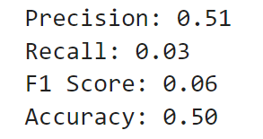

**DIALOGUE:**

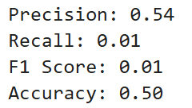

**2. CHAIN-OF-VERSIFICATION (COVe)**

**QA:**

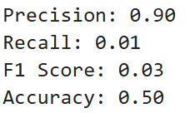

**DIALOGUE:**

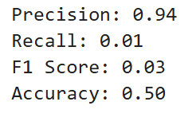

**3. CHAIN-OF-THOUGHT (COT)**

**QA:**

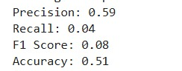

**DIALOGUE:**

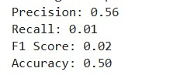

**4. COVe + COT**

**QA:**

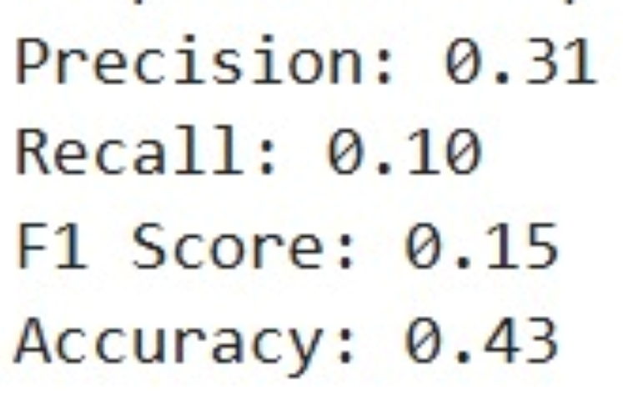

**DIALOGUE:**

